

CSE 523 Machine Learning

Progress Report - 7

Section 1

Date of Submission: 6th April 2022

Group Name: **Bug Smashers**

Group Details

| Roll No | Name |
| --- | --- |
| AU1940028 | Moksh Doshi |
| AU1940120 | Jaimik Patel |
| AU1940130 | Nandish Patel |
| AU1940164 | Jenil Bagadiya |

2022 Winter Semester

# Tasks Performed in the week

* + Applied various algorithm to the processed dataset like:
    1. Decision Tree
    2. SVM
    3. LDA

# Outcomes of the tasks performed

* + Decision tree resulted in an accuracy of 71.055% which is almost similar to that of KNN with K=100 i.e. 71% but marginally smaller than naive bayes done last week having accuracy of 71.911%.

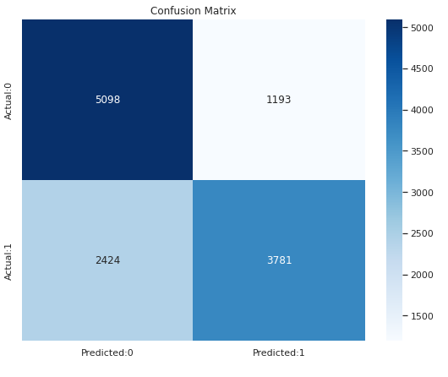

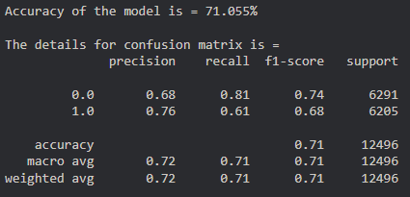

* + Support Vector Machine (SVM) resulted in an accuracy of 72.479% which is highest among all algorithms processed till now beating the next best of 72.27%.

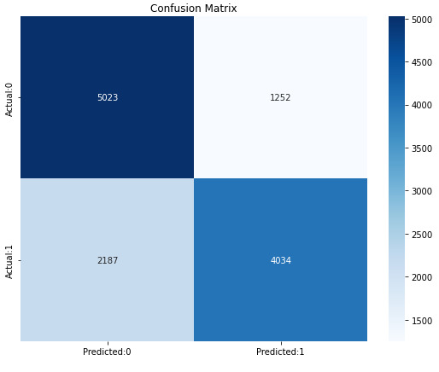

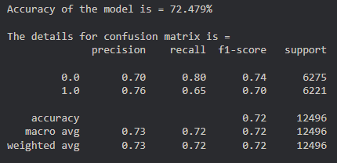

* + Linear Discriminant Analysis (LDA) resulted in an accuracy of 71.991% which is among the average accuracy we have received till now and is the last algorithm we worked on.

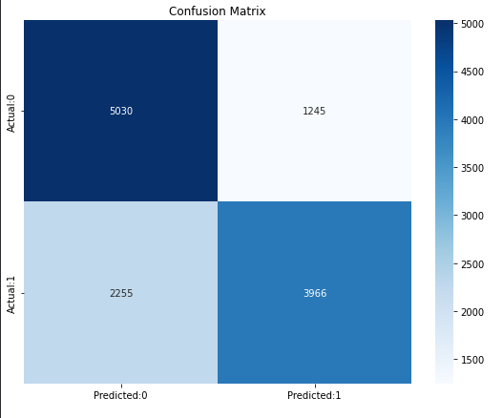

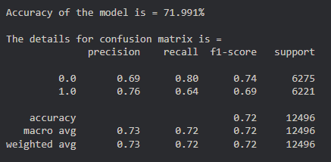

# Tasks to be performed in the upcoming week

* + Explore and apply some methods of dimensionality reduction like PCA